Common givens:

User “Bob Smith” with email [bob.smith@test.com](mailto:bob.smith@test.com) and address “12 somewhere avenue, AV12 C34, UK” is registered as an “Applicant”.

Bob Smith has no previous applications.

Entering application

Give a project page listing projects

Project A123: Lorem ipsum dolor sit amet

Project B256: Nunc in luctus mi.

And Bob is viewing the project page

when bob selects "apply now" for project A123

then bob sees the login page



Given bob is on the login page

when bob enters correct credentials and submits

then bob sees

a page with a section labelled "my applications"

with field "programme name" with value "A123 - Lorem ipsum dolor sit amet"

and field "Application Number" with a value

and sections labelled

"personal details", "address", "qualifications", "Funding", "References", "documents"

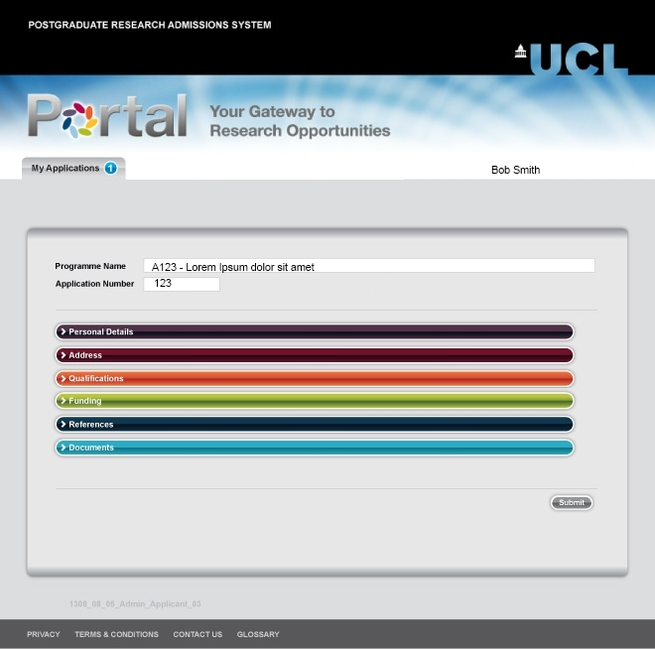

Personal Details

Given bob is viewing the my applications section for application number 123

when bob selects the "personal details" section

then bob will see a personal details record with

"First name" with value "Bob"

"last name" with value "smith"

"email" with value "bob.smith@test.com"

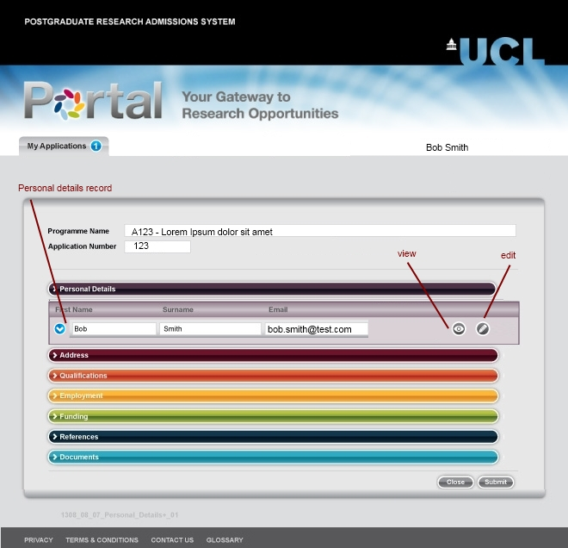

Given bob is viewing the personal details section for application number 123

when bob chooses to view the personal details record

then bob will see a record details section displaying

"First name" with value "Bob"

"last name" with value "smith"

"email" with value "bob.smith@test.com"

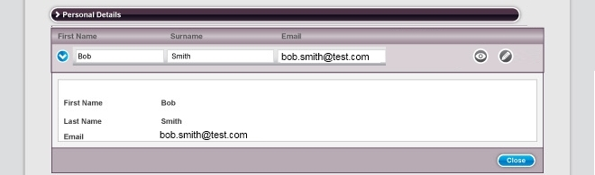

Given bob is viewing the personal details section for application number 123

when bob chooses to edit the personal details record

then bob will see a record details section with editable fields

"First name" with value "Bob"

"last name" with value "smith"

"email" with value "bob.smith@test.com"

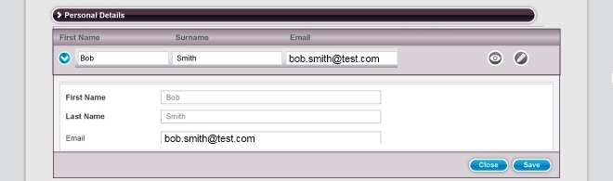

Given bob has chosen to edit personal details for application number 123

when bob enters

"Robert" as first name

"Jones" as last name

"rjones@test.com" email

and choses to close

then record details section disappears and

bob will see a personal details record with

"First name" with value "Bob"

"last name" with value "smith"

"email" with value "bob.smith@test.com"

Given bob has chosen to edit personal details for application number 123

when bob enters

"Robert" as first name

"Jones" as last name

"rjones@test.com" email

and choses to save

then record details section disappears and bob will see a personal details record with

"First name" with value "Robert"

"last name" with value "Jones"

"email" with value "rjones@test.com"



Address

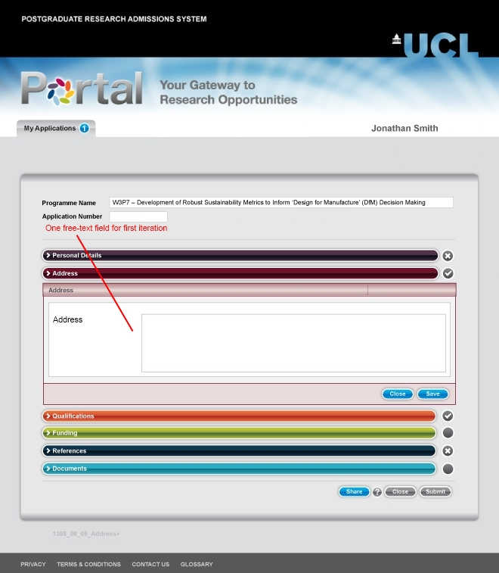

Given bob is viewing the my applications section for application number 123

when bob selects the "address" section

then bob will see a address record with value "12 somewhere avenue, AV12 C34, UK"

Given bob is viewing the address section for application number 123

when bob chooses to view the address record

then bob will see a record details section displaying

"12 somewhere avenue, AV12 C34, UK"

Given bob is viewing the address section for application number 123

when bob chooses to edit the address record

then bob will see a record details section with editable field

"address" with value "12 somewhere avenue, AV12 C34, UK"

Given bob has chosen to edit address for application number 123

when bob enters

"12 anywhere road, AV12 C34, UK"

and choses to close

then record details section disappears and

bob will see a address record with value "12 somewhere avenue, AV12 C34, UK"

Given bob has chosen to edit address for application number 123

when bob enters

"12 anywhere road, AV12 C34, UK"

and choses to save

then record details section disappears and

bob will see a address record with value "12 anywhere road, AV12 C34, UK"

Qualification

Given bob is viewing the my applications section for application number 123

when bob selects the "qualifications" section

then bob will see no qualification records

and be able to choose adding a new qualification



Given bob is viewing the qualifications section for application number 123

when bob chooses to add a qualification

then bob will see a record details section with editable field

"qualification"

"Awarding Body"

"grade"

"date awarded"

that are all empty

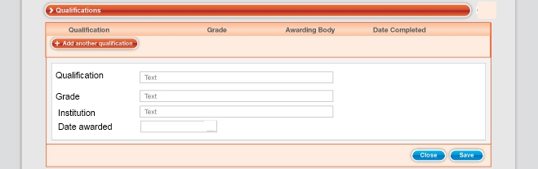

Given bob has chosen to add a qualification for application number 123

when bob enters

"qualification" "Msc Engineering"

"Awarding Body" "Made-Up University"

"grade" "95%"

"Date Awarded" "June 15 2010"

and choses to close

then record details section disappears and

then bob will see no qualification records

and be able to choose adding a new qualification

Given bob has chosen to add aqualifications for application number 123

when bob enters

"qualification" "Msc Engineering"

"Awarding Body" "Made-Up University"

"grade" "95%"

"Date Awarded" "June 15 2010"

and choses to save

then record details section disappears and bob will see a qualification record with

"qualification" "Msc Engineering"

"Awarding Body" "Made-Up University"

"grade" "95%"

"Date Awarded" "June 15 2010"

Given bob has entered quailification

"qualification" "Msc Engineering"

"Awarding Body" "Made-Up University"

"grade" "95%"

"Date Awarded" "June 15 2010" for application number 123

and bob is viewing the qualifications section for application number 123

when bob chooses to view the qualifications record

then bob will see a record details section displaying

"qualification" with value "Msc Engineering"

"Awarding Body"with value "Made-Up University"

"grade" with value "95%"

"Date Awarded" with value "June 15 2010"

Given bob has entered quailification

"qualification" "Msc Engineering"

"Awarding Body" "Made-Up University"

"grade" "95%"

"Date Awarded" "June 15 2010" for application number 123

and bob is viewing the qualifications section for application number 123

when bob chooses to edit the qualifications record

then bob will see a record details section with editable fields

"qualification" with value "Msc Engineering"

"Awarding Body"with value "Made-Up University"

"grade" with value "95%"

"Date Awarded" with value "June 15 2010"

Given bob has entered quailification

"qualification" "Msc Engineering"

"Awarding Body" "Made-Up University"

"grade" "95%"

"Date Awarded" "June 15 2010" for application number 123

and has chosen to edit qualifications for application number 123

when bob enters

"Phd History" as "qualification"

"Invented University" as Awarding Body

"25%" as g"rade "

"October 4 1967" as "Date Awarded"

and choses to close

then record details section disappears and bob will see a record details section displaying

"qualification" with value "Msc Engineering"

"Awarding Body"with value "Made-Up University"

"grade" with value "95%"

"Date Awarded" with value "June 15 2010"

Given bob has entered quailification

"qualification" "Msc Engineering"

"Awarding Body" "Made-Up University"

"grade" "95%"

"Date Awarded" "June 15 2010" for application number 123

and has chosen to edit qualifications for application number 123

when bob enters

"Phd History" as "qualification"

"Invented University " as Awarding Body

"25%" as g"rade "

"October 4 1967" as "Date Awarded"

and choses to save

then record details section disappears and bob will see a record details section displaying

"qualification" with value "Phd History"

"Awarding Body"with value "Invented University"

"grade" with value "25%"%"

"Date Awarded" with value "October 4 1967"

Funding

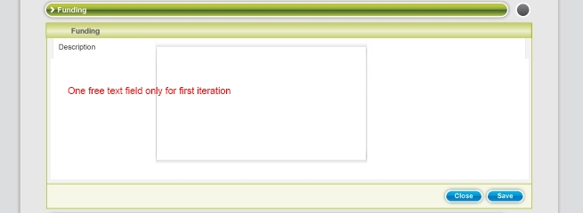

Given bob is viewing the my applications section for application number 123

when bob selects the "funding" section

then bob will see an empty funding record with

Given bob is viewing the funding section for application number 123

when bob chooses to view the funding record

then bob will see a record details section displaying

"description" with no value

Given bob is viewing the funding section for application number 123

when bob chooses to edit the funding record

then bob will see a record details section with editable fields

"description" with no value

Given bob has chosen to edit funding for application number 123

when bob enters

"Scholarship abc" in the "description" filed and chooses to close

then record details section disappears and

bob will see an empty funding record with

Given bob has chosen to edit funding for application number 123

when bob enters

"Scholarship abc" in the "description" filed and chooses to save

then record details section disappears and bob will see a funding record with

"description" "sholarship abc"